**Online Quiz Management System**

A mini-project report submitted for

**Internet Programming (Semester V)**

by

Smith Dabreo (8382)

Brian Dias (8384)

Under the guidance of

Prof. Saurabh Kulkarni

(sign with date)



**Approval Sheet**

**Project Report Approval**

This project report entitled by **Project Title With Every First Letter in Upper**

**Case** by **Student 1, Student 2, and Student 3** is approved as mini project in Third year Engineering, Information Technology.

Examiners

1.——————————

1. _____________________

2.——————————

Date:

Place:

**Abstract**

The purpose of our project is to create an Online Quiz system which is able to provide teachers the means to create effective syllabus based quizzes for students to participate in. In this project we also provide the students a means to participate in the quizzes put up by the teachers and also manage them. The students can take quizzes any time anywhere and also give feedback about them to the teachers. The teacher can view the marks scored by the students. This project consists of computerized grading as teacher can select the right answer while creating the quiz also it consists of a marking scheme which teachers can set. Students can view his/her quiz history and also see ranking.

**Table of Content**

|  |  |  |
| --- | --- | --- |
| Sr. No | Topic | Page No. |
| 1. | Introduction | 9 |
| 2. | Brief Explanation of the project | 10 |
| 2.1. | Design process of the project | 10 |
| 2.2 | Front End Design | 11 |
| 2.3 | Database Design | 14 |
| 3. | Process used to make website responsive | 17 |
| 4. | Process used to include RIA to website | 19 |
| 5. | Process of interfacing front end with the back end | 20 |
| 6. | Testing of the website | 22 |
| 7. | Future Scope | 28 |
| 8. | Appendix | 29 |
| 8.1 | Assignment 1 |  |
| 8.2 | Assignment 2 |  |
| 8.3 | Certificate of any web related course done (if any) | - |

ITC502.1: Design interactive web page(s) using HTML, CSS and JavaScript.

Rubrics for the assessment:

|  |  |  |  |  |  |
| --- | --- | --- | --- | --- | --- |
| Indicator | Very Poor | Poor | Average | Good | Excellent |
| Timeline  (2) | More than a session late (0) | NA(0.5) | NA(1) | NA(1.5) | Early or on  time (2) |
| Code design(4) | NA  (0) | Very poor code design with no comments and indentation(1) | Poor code design with very comments and indentation  (2) | Design with good coding standards (3) | Accurate design with better coding standards (4) |
| Dynamic Web pages in the website  (4) | Website does not have dynamic web pages (0) | Very few pages are dynamic pages (1) | Very few pages are dynamic with event handling mechanisms(2) | Appropriate use of event handling for making web pages dynamic (3) | Sufficient number of dynamic web pages along with appropriate event handling mechanisms (4) |

ITC502.2: Design a responsive web site using HTML5 and CSS3.

Rubrics for the assessment:

|  |  |  |  |  |  |
| --- | --- | --- | --- | --- | --- |
| Indicator | Very Poor | Poor | Average | Good | Excellent |
| Timeline  (2) | More than a session late (0) | NA(0.5) | NA(1) | NA(1.5) | Early or on  time (2) |
| Code design(4) | NA  (0) | Very poor code design with no comments and indentation(1) | Poor code design with very comments and indentation  (2) | Design with good coding standards (3) | Accurate design with better coding standards (4) |
| Responsiveness of the website  (4) | Website is not responsive (0) | Few parts of the website are responsive and scale well on few devices(1) | Many parts of the website are responsive but work on few devices (2) | Many parts of the website are responsive and work on majority of the devices (3) | Almost all parts of the website are responsive and work on almost all devices (4) |

ITC502.3: Develop Rich Internet Application.

Rubrics for the assessment:

|  |  |  |  |  |  |
| --- | --- | --- | --- | --- | --- |
| Indicator | Very Poor | Poor | Average | Good | Excellent |
| Timeline  (2) | More than a session late (0) | NA(0.5) | NA(1) | NA(1.5) | Early or on  time (2) |
| Code design(4) | NA  (0) | Very poor code design with no comments and indentation(1) | Poor code design with very comments and indentation  (2) | Design with good coding standards (3) | Accurate design with better coding standards (4) |
| RIA on the website  (4) | Website does not have RIA(0) | Many errors in the AJAX code(1) | Few errors in the AJAX code (2) | AJAX code with minimal errors(3) | Error free AJAX code performing the desired task (4) |

ITC502.4: Build Dynamic web site using server side Programming and Database connectivity.

Rubrics for the assessment:

|  |  |  |  |  |  |
| --- | --- | --- | --- | --- | --- |
| Indicator | Very Poor | Poor | Average | Good | Excellent |
| Timeline  (2) | More than a session late (0) | NA(0.5) | NA(1) | NA(1.5) | Early or on  time (2) |
| Code design(4) | NA  (0) | Very poor code design with no comments and indentation(1) | Poor code design with very comments and indentation  (2) | Design with good coding standards (3) | Accurate design with better coding standards (4) |
| Server side Programming and database connectivity  (4) | Website with no database connectivity(0) | Website with no validations from the database (1) | Website with database connectivity but poor database design (2) | Website with database connectivity with good database design (3) | Website with database connectivity with good database design and better performance(4) |

**Chapter 1**

**Introduction**

This project aims for providing a better experience of to the students and teachers in participating and creating quizzes respectively. This website has the option for teachers to create quizzes as per requirement they can add time limit to the quizzes also the teacher have the freedom to apply any marking scheme of their choice even negative marking is available teachers are able to see the marks acquire by the students there’s also a feature for deleting outdated quizzes

This website also aims at providing features to students like students can browse through the quizzes put up by teachers and participate in them. They can also see their respective marks right after finishing the quiz, a ranking system is also available for students to view. This encourages the students to work hard in their studies and take fun, interesting and interactive quizzes

The teachers(admin) have the privileges to view feedbacks given by the students and work on it. Teachers are also able to remove particular user, etc.

The technologies used in creating this project are as follows: PHP, MySQL for the backend. HTML, CSS, Bootstrap, JavaScript for the frontend.

The websites like allindiaexams.in and edudose.com are a little bit similar in concept of the quiz participation but quite different too at the same time they have many more functionalities whereas this website is exclusively made for students and teachers that’s it.

**Chapter 2**

**Brief Explanation of the project**

**2.1 Design Process of the Project:**

Designing of a website mainly includes two major parts:

**1.Front End:** At first a draft was made on how the front end would look on a rough paper. The next part of our process was deciding the given languages which we would use. We have used HTML for the main web page and CSS and BOOTSTRAP for the given styling and designing of the web pages. JAVA SCRIPT has also been used thoroughly for the different linkages of the front End and back end.

**2.Back End:** After the front End was roughly prepared we decided to switch towards the back end. The languages used to draft the back end were PHP and MYSQL. PHP was mainly used for the entire backend by creating dynamic webpages in HTML as per the requirement. MYSQL was used to store the given entries of the teacher and students.

**2.2 Front End Design:**

Student Homepage: This is a simple student homepage designed using bootstrap, and is made effective by giving it a navigation bar, consisting of different links to navigate to different web pages.

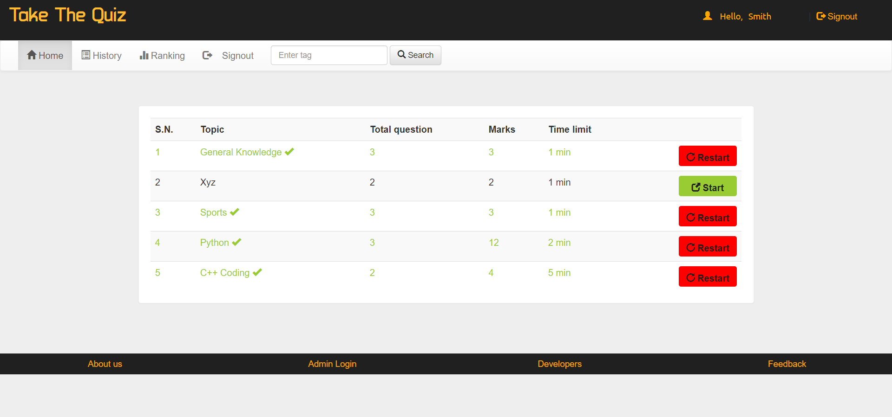

Teacher Homepage: This is a simple teacher homepage designed using bootstrap, and is made effective by giving it a navigation bar, consisting of different links to navigate to different web pages

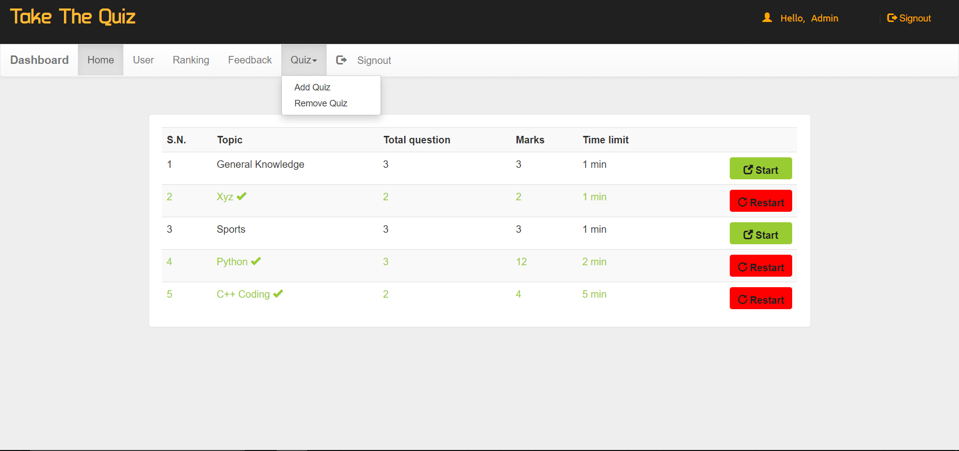

Login/Signup Page: This is the login/signup page where a student or a teacher can login/signup to enter into the main website. This page is made by inserting an image in the background, basic bootstrap and creating a form.

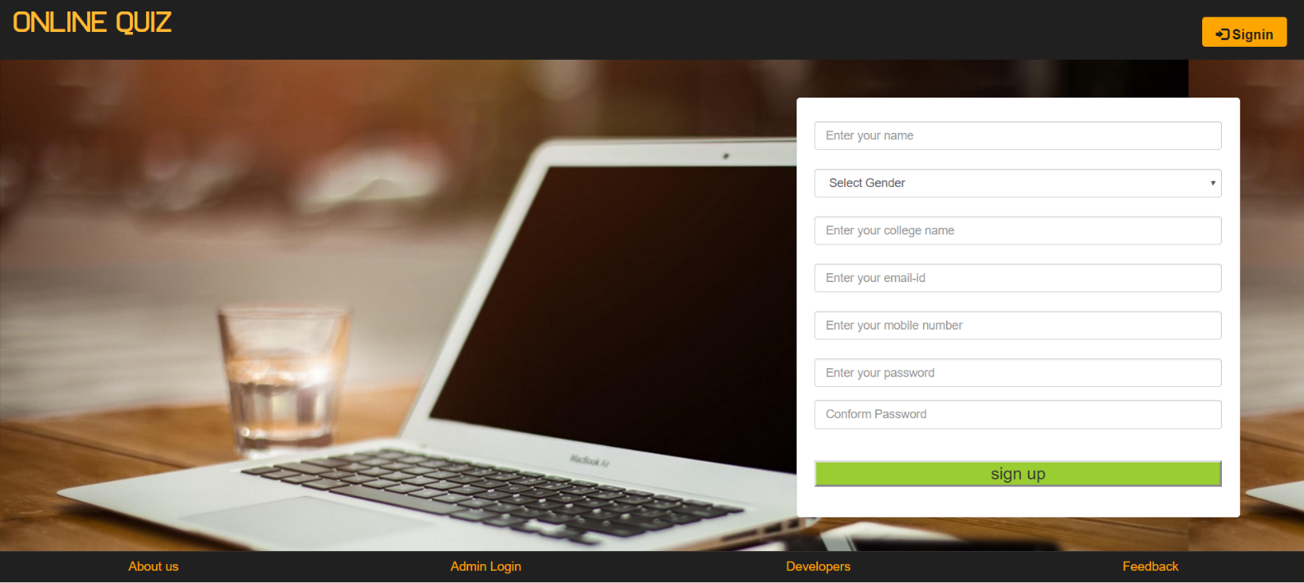

Make a Quiz Page: This page can only be accessed by teacher, it is used to make a quiz teacher can select no of questions quiz topic, etc.

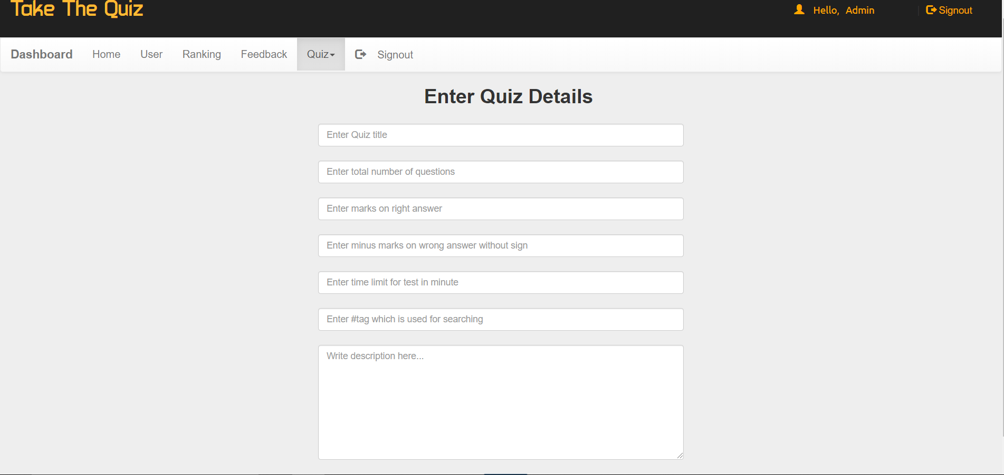

Take a Quiz Page: Students can participate in a quiz by clicking start button located at the end of every quiz topic in the student homepage.

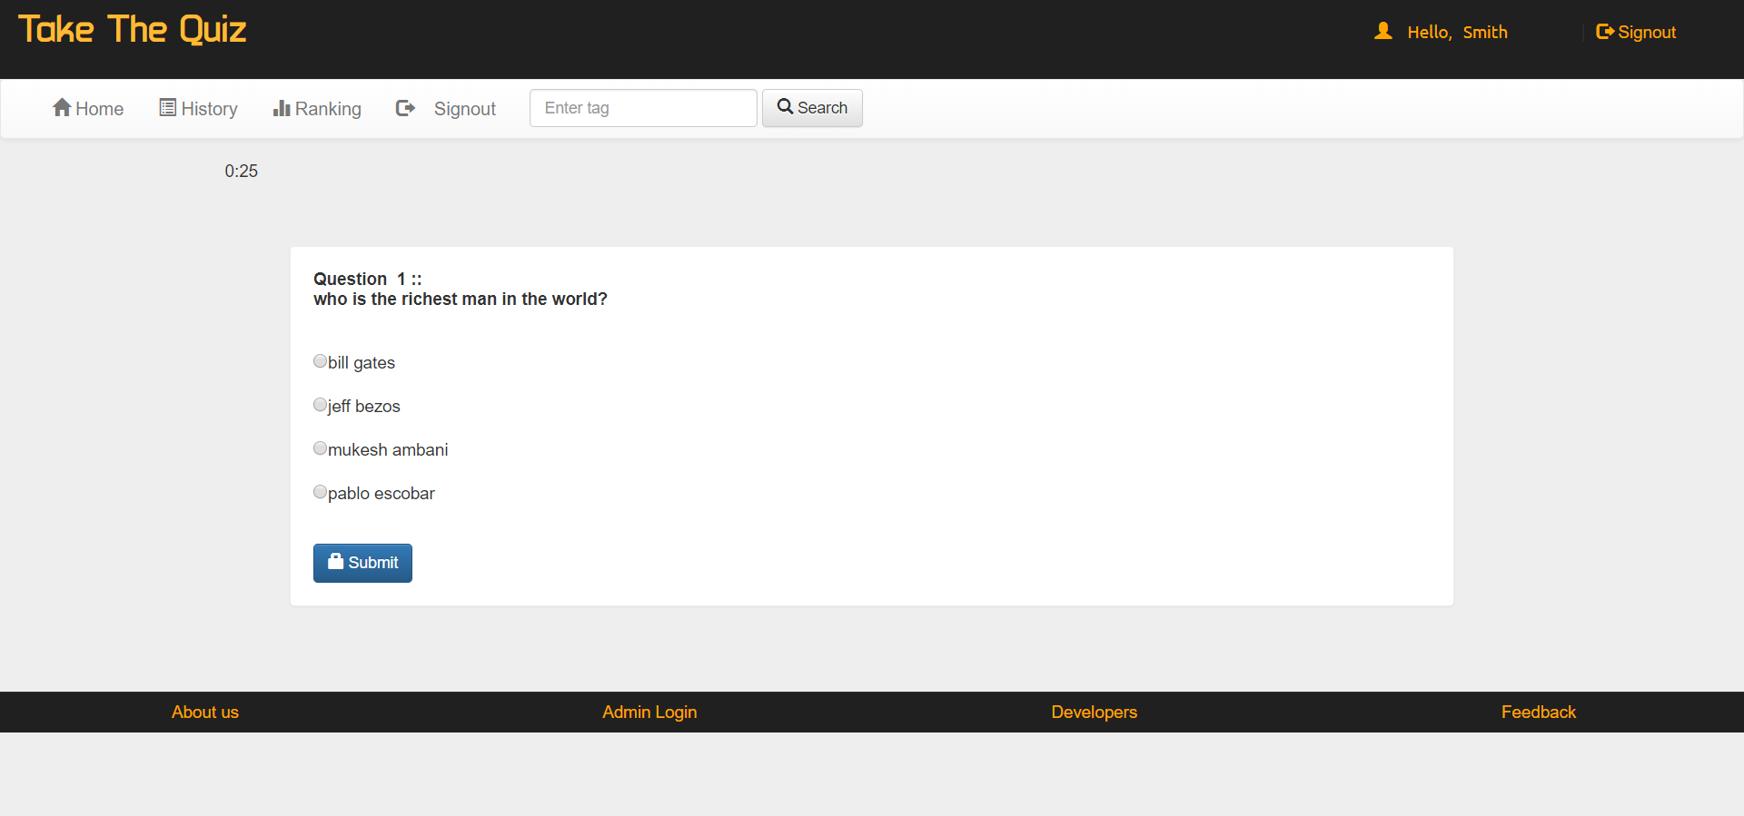

**2.3 Database design:**

PHP was used to connect the desired backend to MySql database. We could get multiple entries at the same time

Different functions are made to easily identify which part of the data is called and identification of data for a given task is easily done

The database has been created using MySQl.

The whole database was created in file named project.sql

Containing tables like:

* admin
* answer
* feedback
* history
* options
* questions
* quiz
* rank
* user

project.sql:

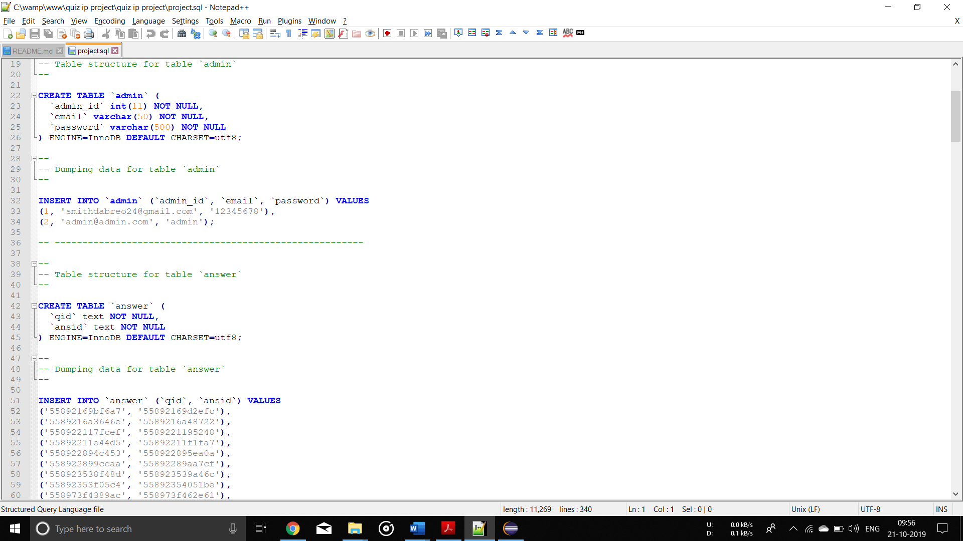

DATABASE TABLES EXAMPLES :

User Reg Table:

|  |  |  |  |
| --- | --- | --- | --- |
| NAME | NULL/NOTNULL | TYPE | KEY |
| GENDER | NULL | VARCHAR(10) |  |
| COLLEGE | NULL | VARCHAR(50) |  |
| EID | NOTNULL | VARCHAR(50) | PRIMARYKEY |
| UID | NULL | VARCHAR(20) |  |
| PWD | NULL | VARCHAR(20) |  |
| RPWD | NULL | VARCHAR(20) |  |

Multiple Choice Question Table:

|  |  |  |  |
| --- | --- | --- | --- |
| NAME | NULL/NOTNULL | TYPE | KEY |
| QID | NOTNULL | INT | PRIMARYKEY |
| QN | NULL | VARCHAR(500) |  |
| OPTIONS1 | NULL | VARCHAR(100) |  |
| OPTIONS2 | NULL | VARCHAR(100) |  |
| OPTIONS3 | NULL | VARCHAR(100) |  |
| OPTIONS4 | NULL | VARCHAR(100) |  |
| ANSWER | NULL | VARCHAR(100) |  |

Multiple Choice Answer Table:

|  |  |  |  |
| --- | --- | --- | --- |
| NAME | NULL/NOTNULL | TYPE | KEY |
| QID | NOTNULL | INT | FOREIGNKEY |
| ANSWER | NULL | VARCHAR(10) |  |

Rankings Table:

|  |  |  |  |
| --- | --- | --- | --- |
| RANK | NULL | INT |  |
| NAME | NULL/NOTNULL | TYPE | KEY |
| GENDER | NULL/NOTNULL | VARCHAR(10) |  |
| COLLEGE | NULL | VARCHAR(10) |  |
| MARKS | NULL | INT |  |

**Chapter 3**

**Process used to make website responsive**

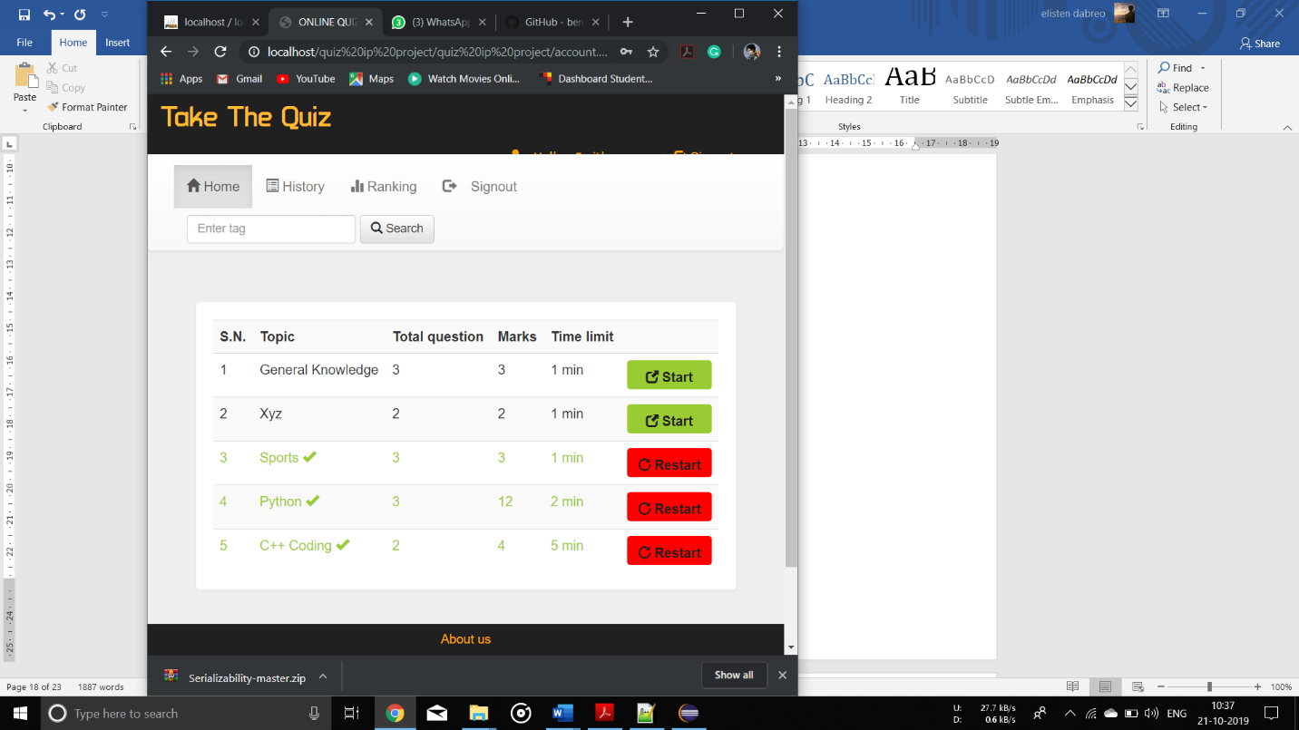

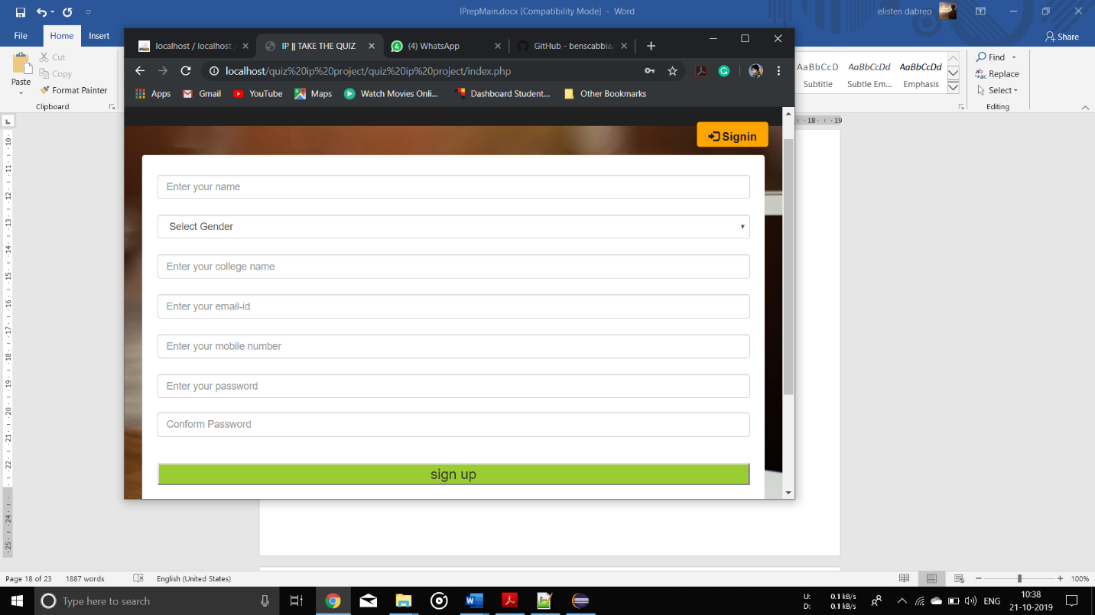

As we can see above the pages in the given project are responsive as even after resizing the given pages the content is clearly visible without any matter or content been cut off

To make the given pages responsive, we have used CSS resizing and Bootstrap, Bootstrap uses mobile first approach to create responsive websites. As per mobile first approach, bootstrap emphasizes to first create the website for mobile devices and later enhancing and enriching the website render it on other large devices as well.

Bootstrap categories different devices in 4 categories on the basis of device width such as extra small devices, small devices, medium devices and large devices. Bootstrap provides different notation based on these categories and defines CSS classes on the basis of that.

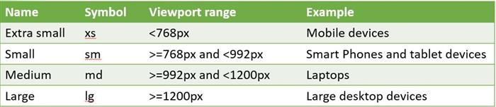

* All the devices having width <768px fall in the category of extra small devices such as mobile devices. Bootstrap provide "xs" to represent these devices.
* All the devices having width >=768px and <992px are fall in the category of small devices such as tablet devices. Bootstrap provide "sm" to represent these devices.
* All the devices having width >=992px and <1200px are fall in the category of medium devices such as laptop devices. Bootstrap provide "md" to represent these devices.
* All the devices having width >=1200px are fall in the category of large devices such as large desktop devices. Bootstrap provide "lg" symbol to represent these devices.

**Chapter 4**

**Process used to include RIA to website**

AJAX =Asynchronous JavaScript And XML.

AJAX is not a programming language.

AJAX just uses a combination of:

* A browser built-in XMLHttpRequest object (to request data from a web server)
* JavaScript and HTML DOM (to display or use the data)

AJAX allows web pages to be updated asynchronously by exchanging data with a web server behind the scenes. This means that it is possible to update parts of a web page, without reloading the whole page.

The beloe screenshot shows the use of ajax in the websit

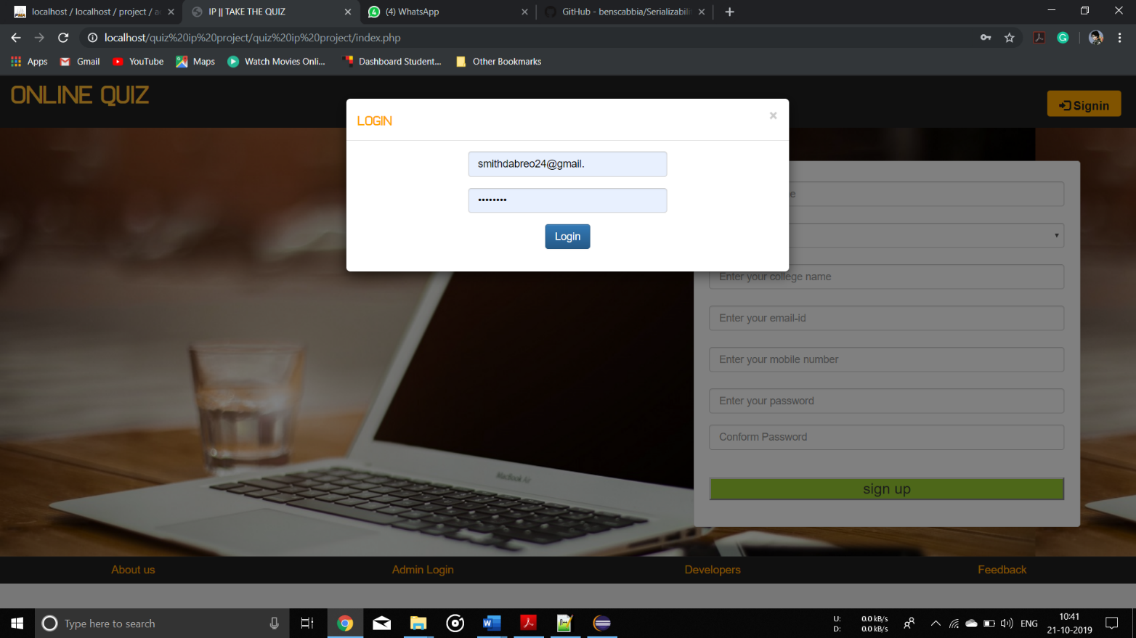

**Chapter 5**

**Process of interfacing front end with the back end**

Let’s take an example where the value taken from the database and is displayed to the user from the database

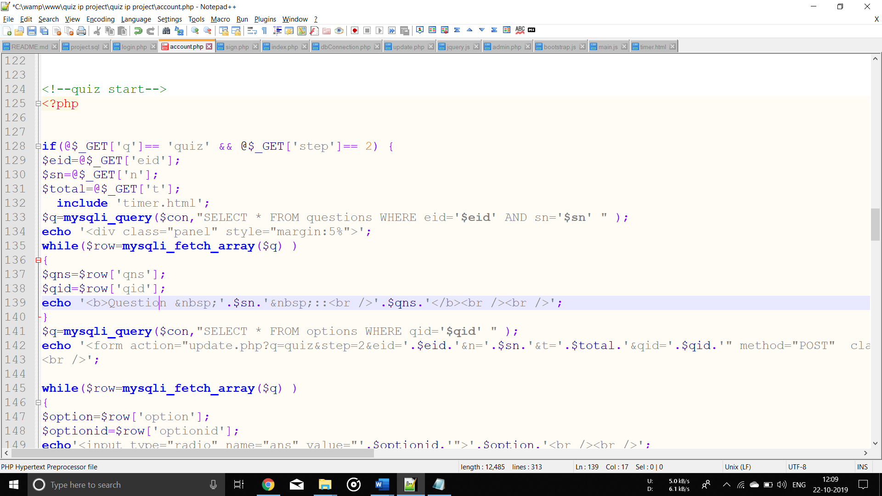

For displaying the question first the question id(eid) and serial number(sn) is stored in database object $q after that the first array will be fetched from $q and stored in $row and then the serial number(sn) of question and question(qns) will be displayed. The same will happen with the options, then the options will be fetched from the database and it will be displayed to the user. Also, the radio button is included before each option.

Just like this the whole database is interfaced with the frontend

**Chapter 6**

**Testing of the website**

Testing of a website is the most important part. While testing each and every function is tested thoroughly. All the errors which arise while testing are solved there and there or they are noted down for solving them afterwards.

Some test performed by us:

* Registering a student

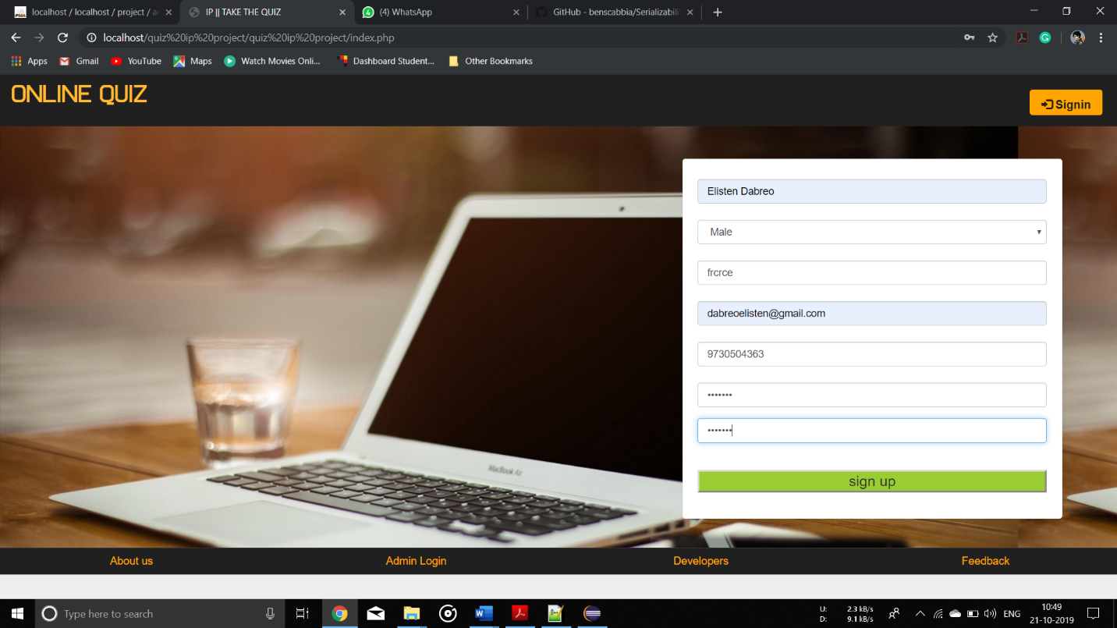

* After registering homepage will appear you can start taking the quiz now

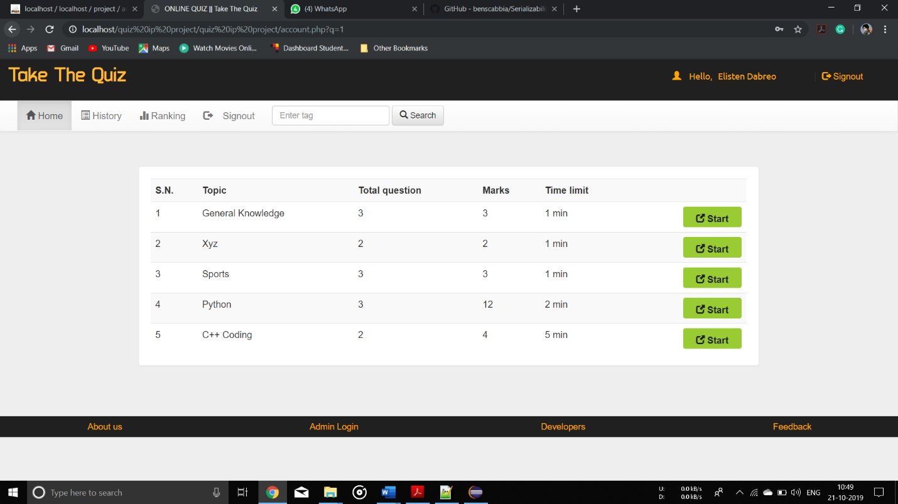

* Taking the quiz



* Viewing the result after quiz completion

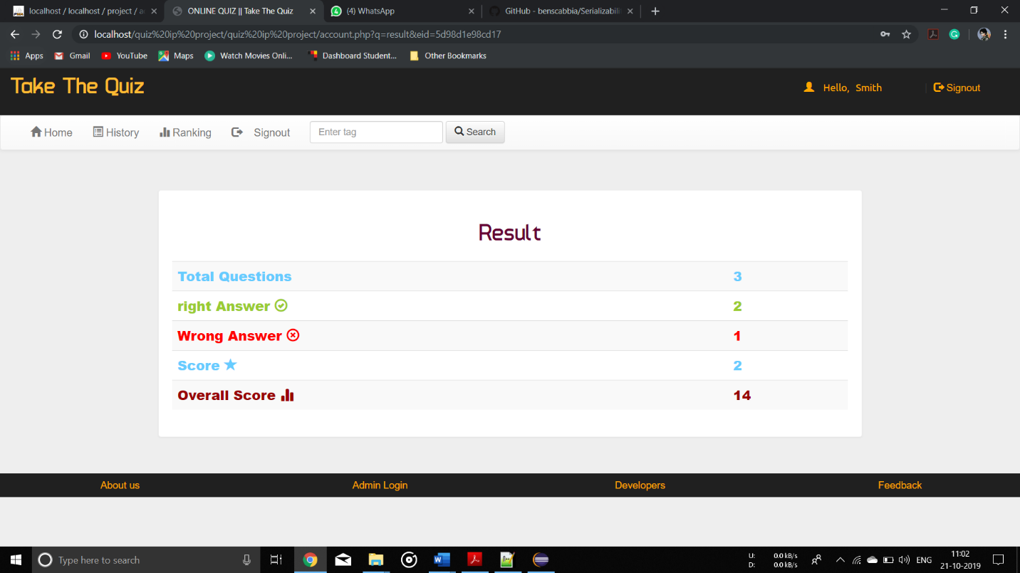

* Submitting feedback

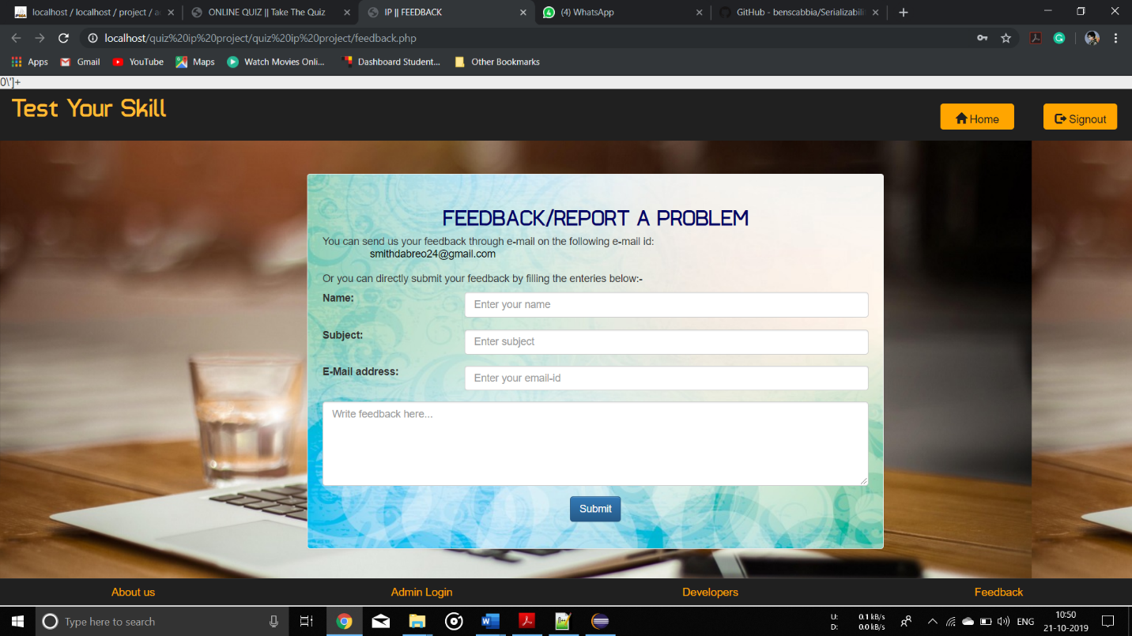

* Admin login

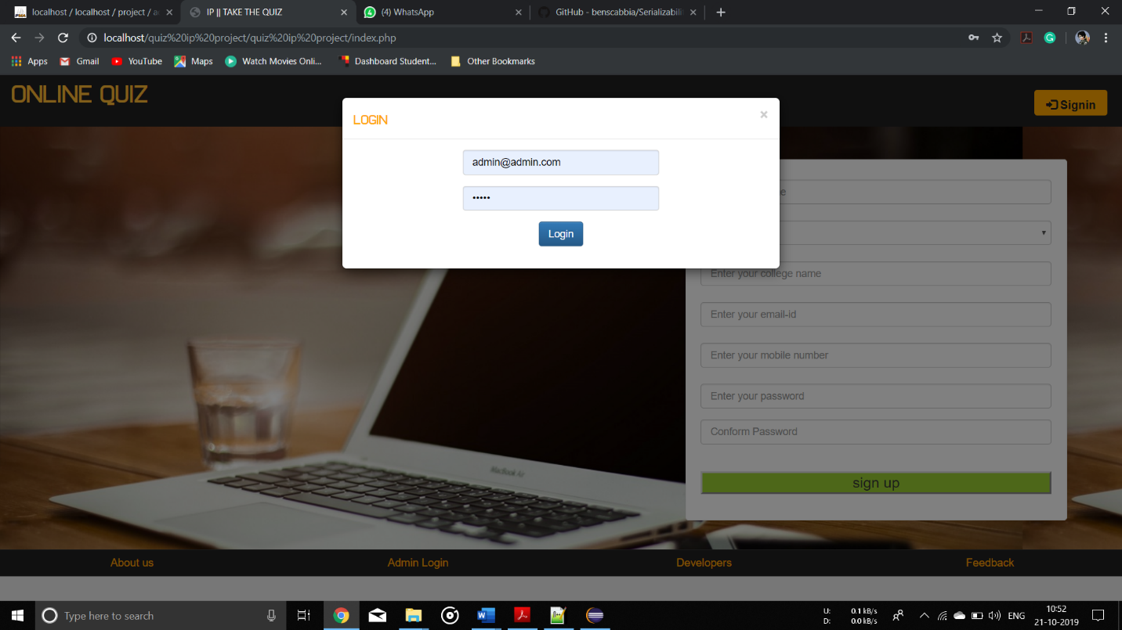

* Creating quiz

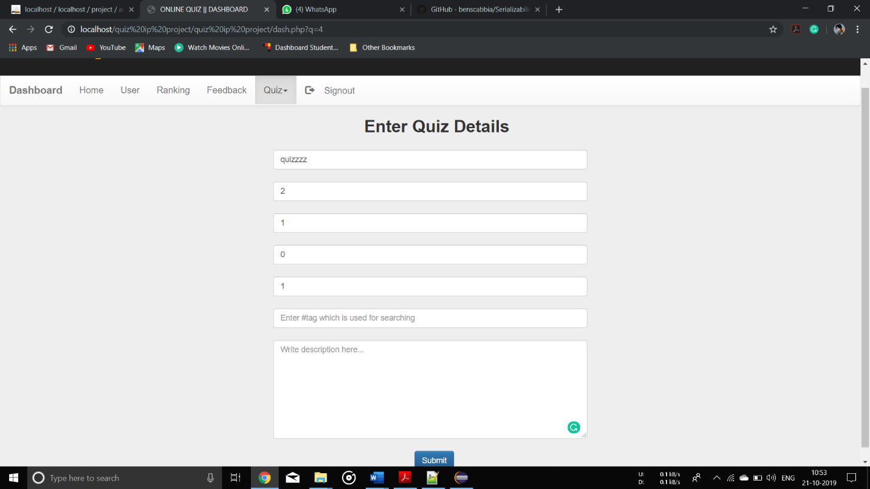

* Entering MCQs

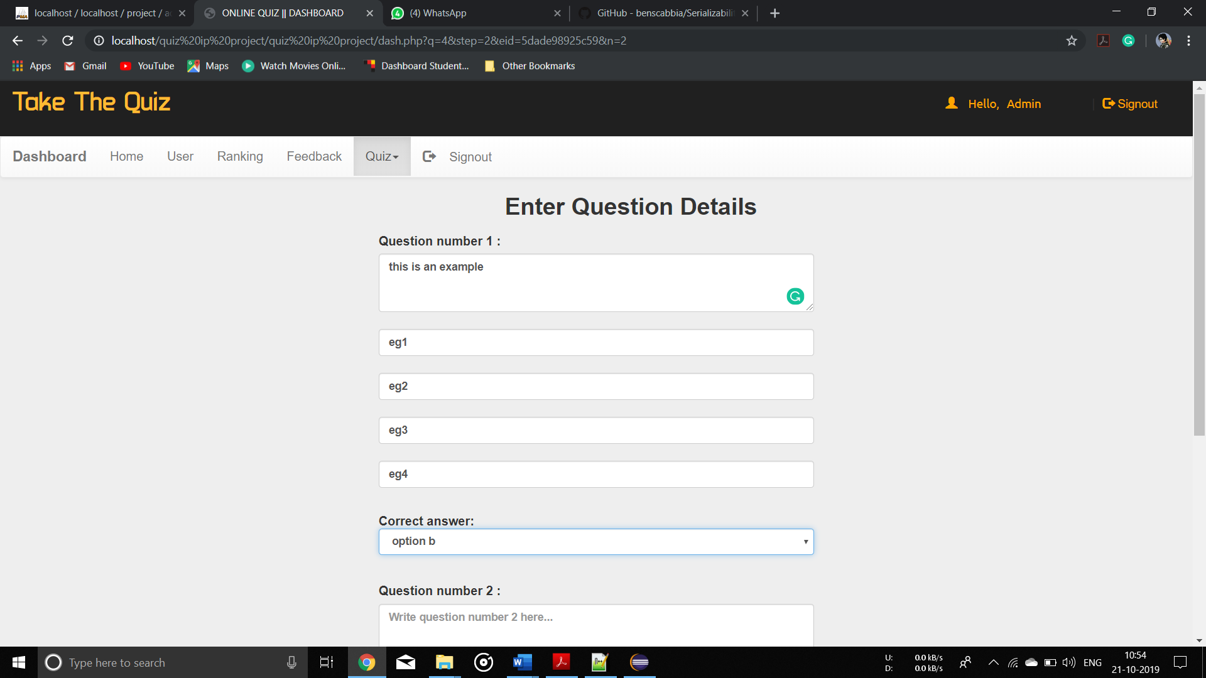

* Deleting quiz

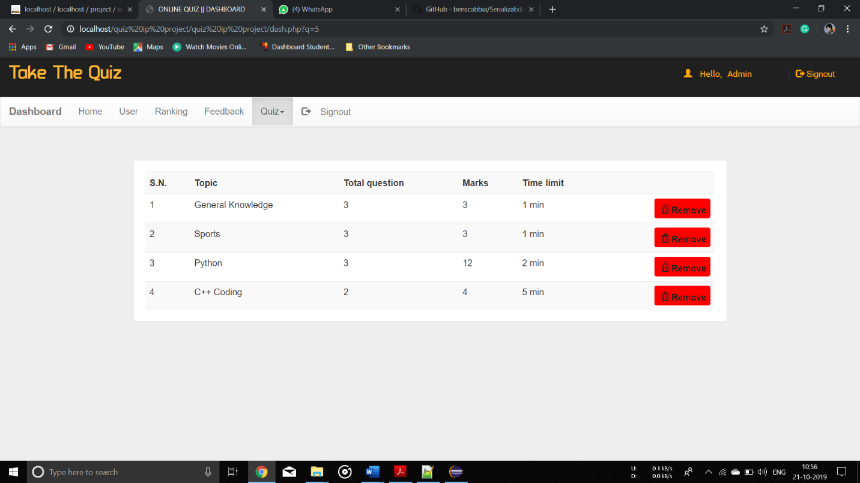

* When no questions and answers were entered and the quiz was created any way and when the same quiz was played by the student this occurs.

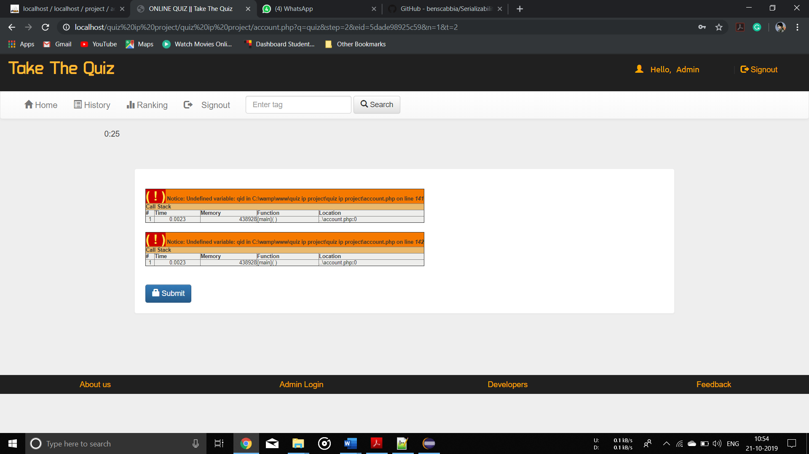

* Error when invalid login credentials were entered

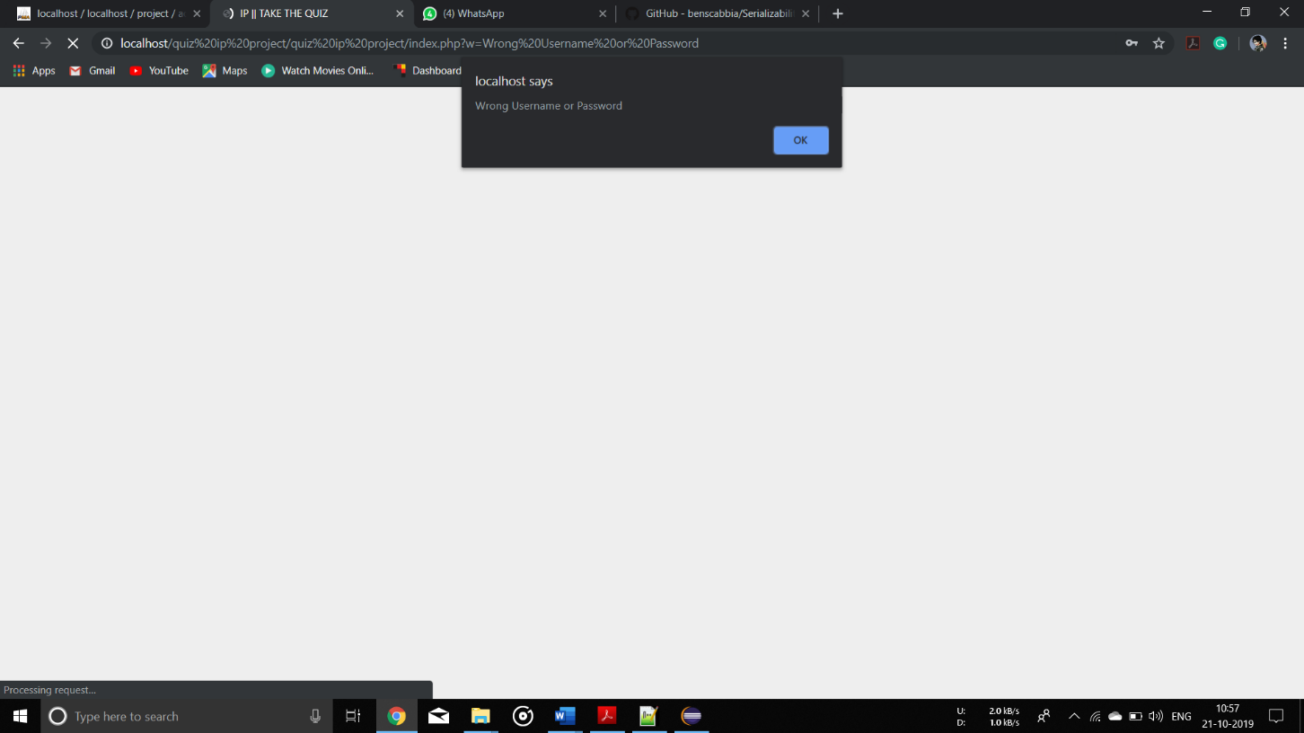

**Chapter 7**

**Future Scope**

* For now only Multiple choice questions are supported, in future we could add other types of question answer techniques.
* In future we can add a feature where after the test the student can see which answers were wrong and which were correct. Also, what was the right answer, etc.
* We can add a question bank system where teacher can upload a question bank beforehand of the test.
* We could also add notes section where students are able to download free ebooks or paid ebooks for the upcoming test.
* In future, a reward based system can be added where a student who tops the test will get some incentives.

Appendix

Attach Assignment 1 with rubrics

Attach Assignment 2 with rubrics

Attach Certificate of the web programming related course done if any